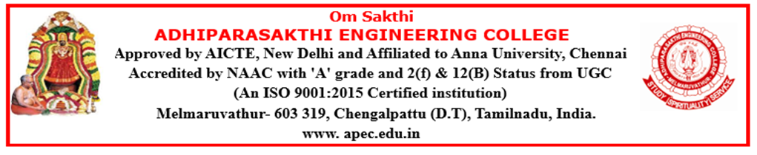

DEPARTMENT OF COMPUTER SCIENCE AND ENGINEERING
ACADEMIC YEAR (2026-2027) ODD SEMESTER

NEWS LETTER
The Times of Neural APEC
2026-2027
JULY

DEPARTMENT ACTIVITIES
CYBERSECURITY TRAINING PROGRAM FOR THIRD-YEAR STUDENTS
Cybersecurity Training Program was successfully conducted for third-year students from 01 July 2026 to 15 July 2026, providing hands-on knowledge and practical skills in cybersecurity concepts and practices.
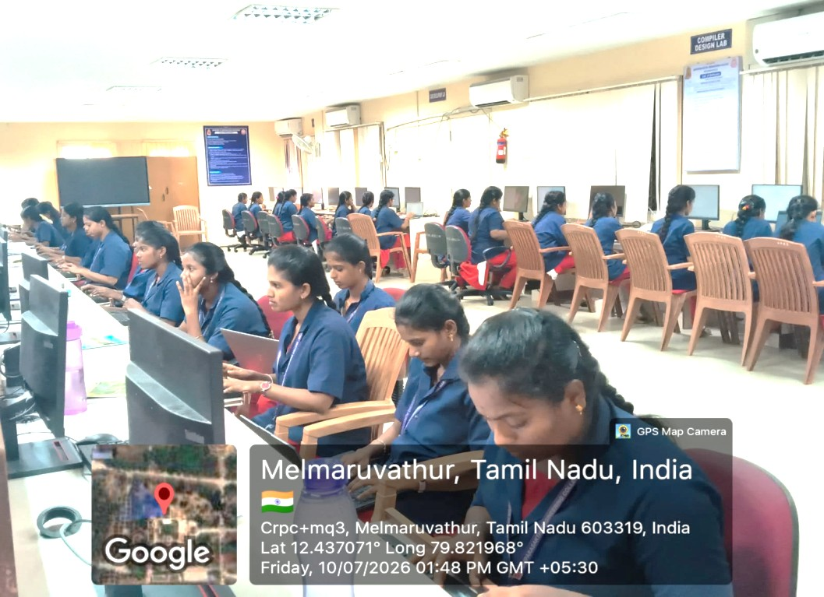
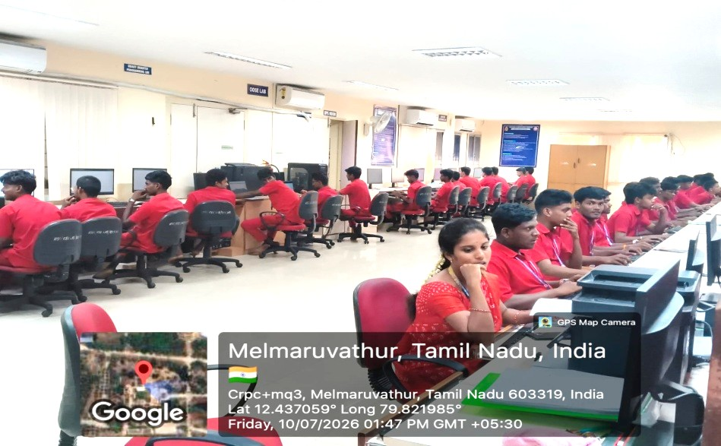
JAVA TRAINING PROGRAM FOR SECOND-YEAR STUDENTS
A Java Training Program was successfully conducted for second-year students from 15 July 2026 to 28 July 2026, enhancing their programming skills through hands-on learning and practical application of Java concepts.
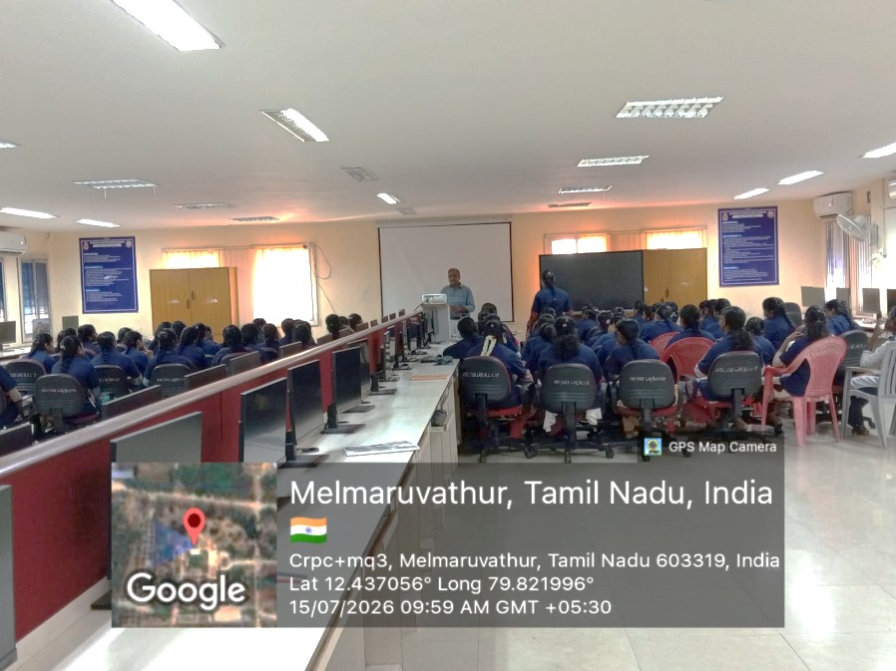
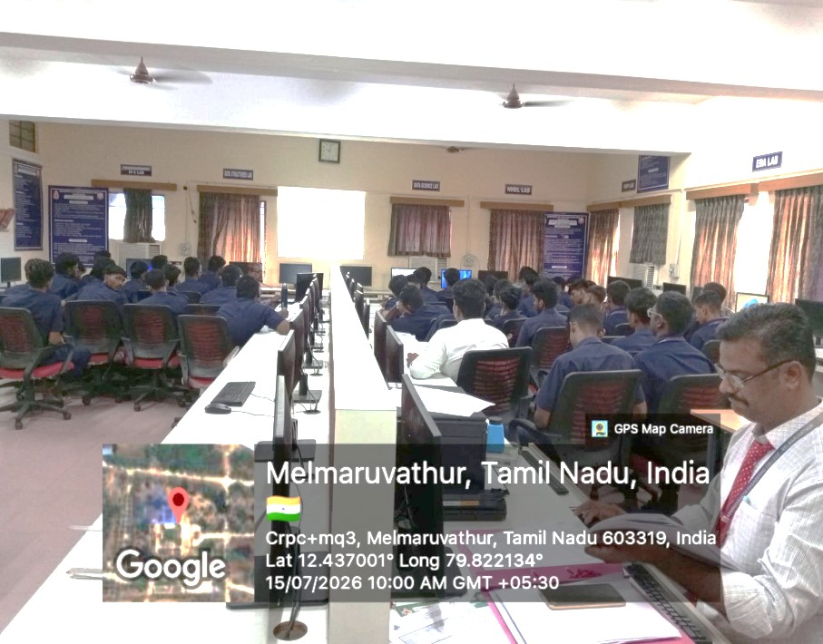

PARENTS MEETING
The II Year Parents’ Meeting was successfully conducted on 11 July 2026 to discuss students' academic progress, attendance, and overall development, while strengthening collaboration between parents and the institution.
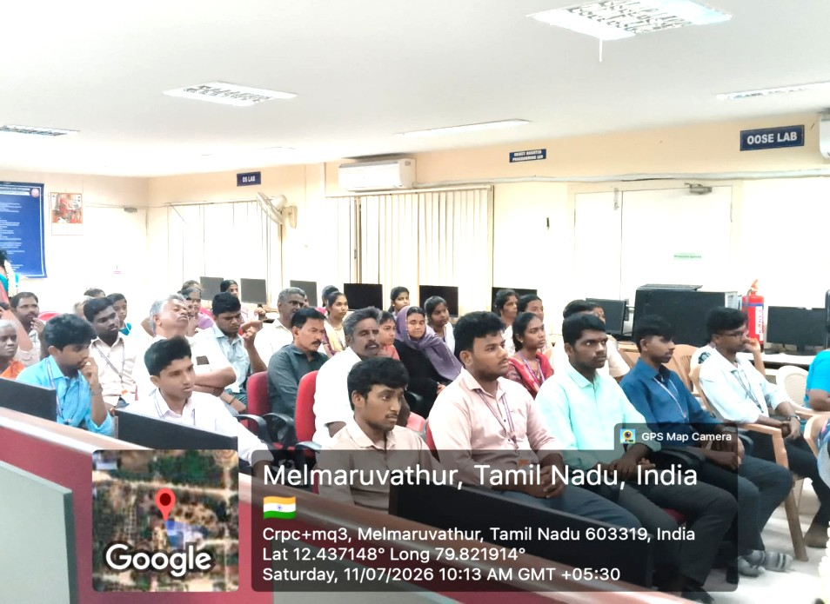
A Parents–Teachers Meeting for final-year students was successfully conducted on 18 July 2026 to discuss academic performance, placement readiness, and overall student progress, fostering effective collaboration between parents and faculty.
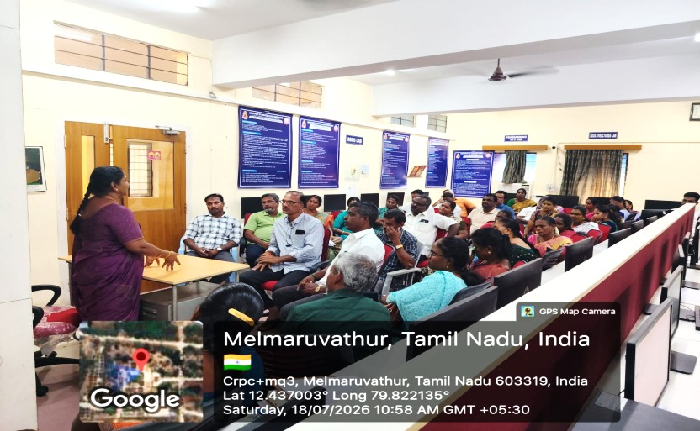

CLASS COMMITTEE MEETING
A Class Committee Meeting for second-year students was successfully conducted on 14 July 2026 to review academic progress, address student feedback, and discuss measures for enhancing the teaching–learning process.
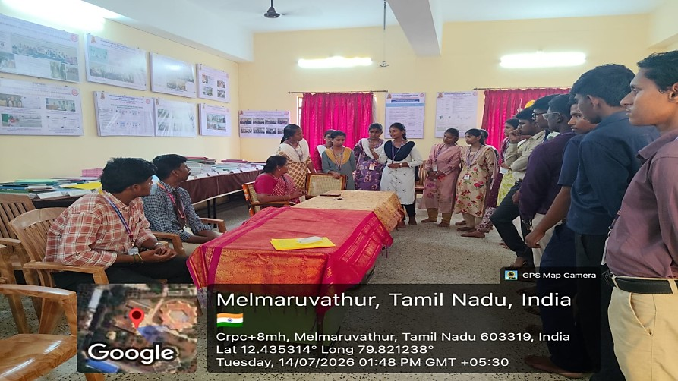
A Class Committee Meeting for third-year students was successfully conducted on 24 July 2026 to review academic progress, discuss student feedback, and identify measures to enhance the teaching–learning process.
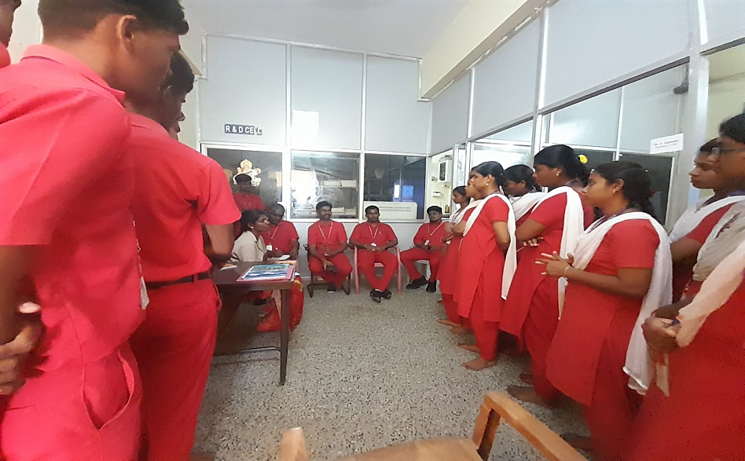
SATURDAY ACTIVITY HIGHLIGHTS [18.07.2026]
Saturday Activity Day (No Bag Day) was successfully conducted on 18 July 2026 for second-year and third-year students, providing opportunities to participate in creative, technical, and recreational activities beyond regular classroom learning.
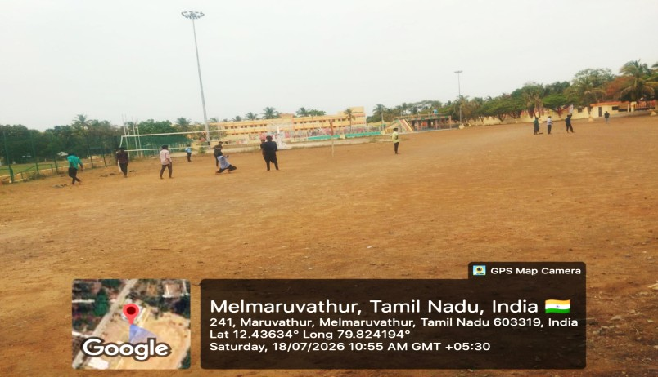

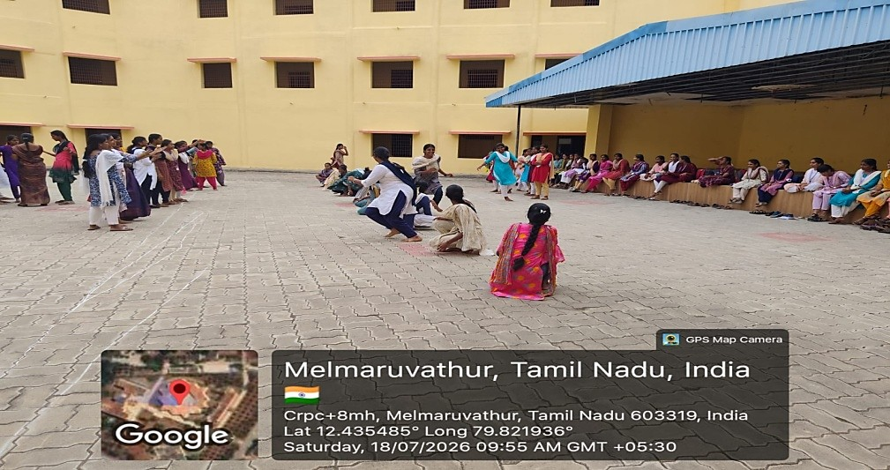

A workshop on Basics of Software Engineering and System Design was conducted for final-year students on 18 July 2026 to strengthen their understanding of software development principles, system design concepts, and industry best practices.
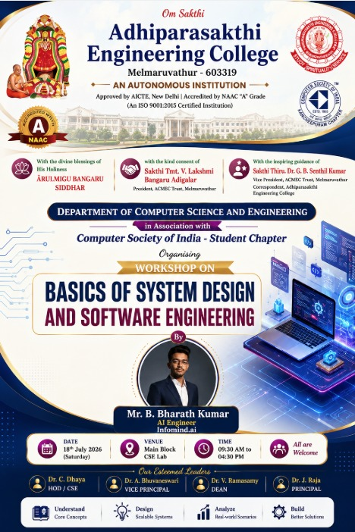
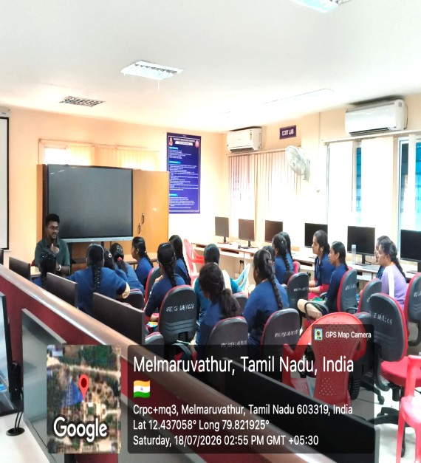
RECOGNITION FOR EXCELLENCE – CSI AWARDS
Our Department proudly participated in the CSI Kancheepuram Chapter – Region VII Awards Ceremony for the Academic Year 2025–2026 on 25.7.26 and received awards in various categories, recognizing its outstanding achievements and contributions.
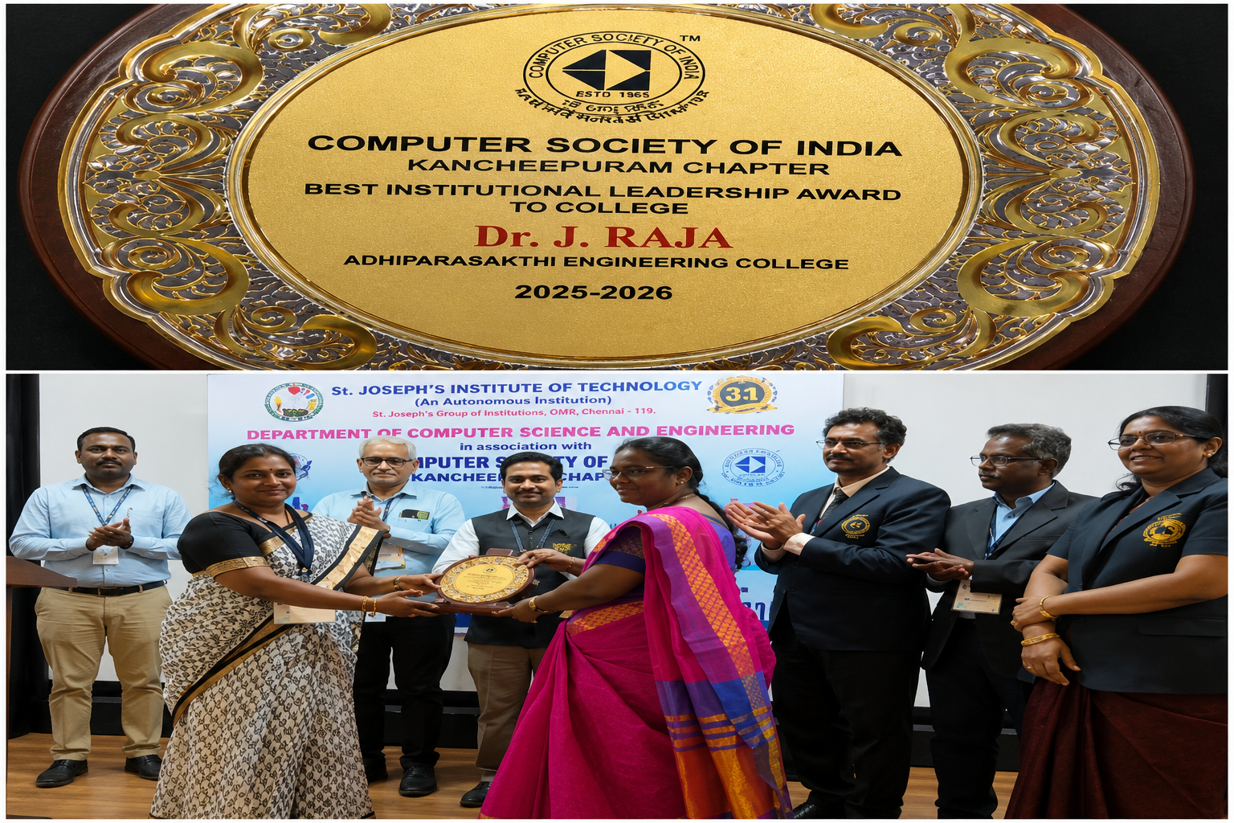
Dr. J. RAJA - Best Institutional Leadership Award
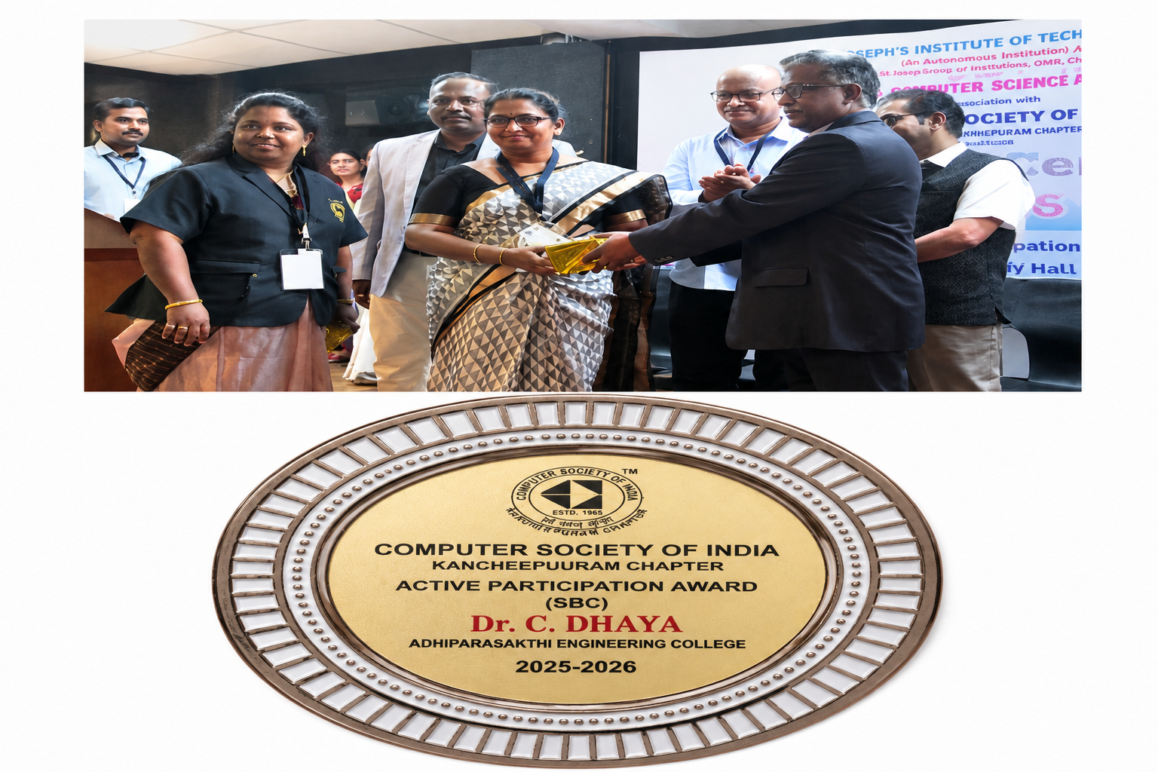
Dr. C. Dhaya - Active participation Award(SBC)
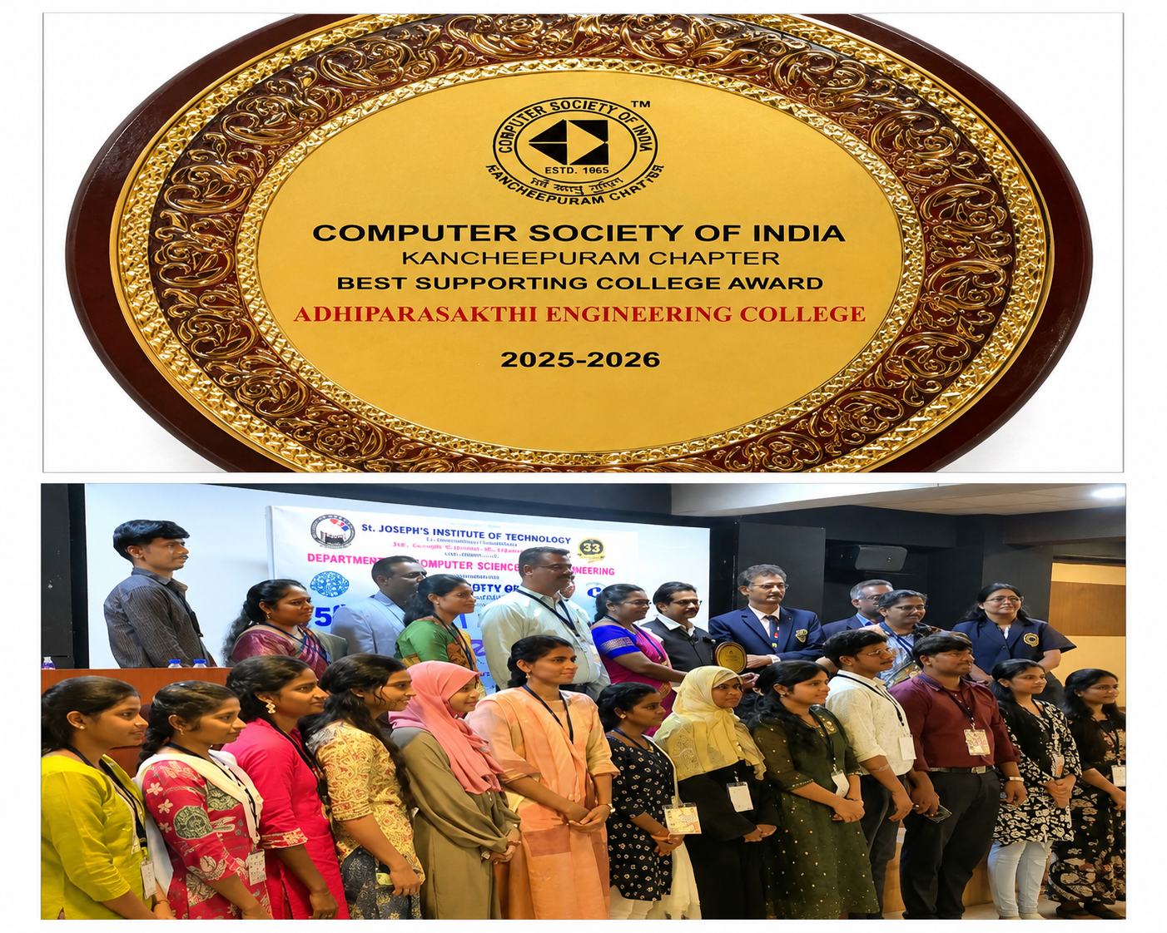
Best supporting College Award 2026

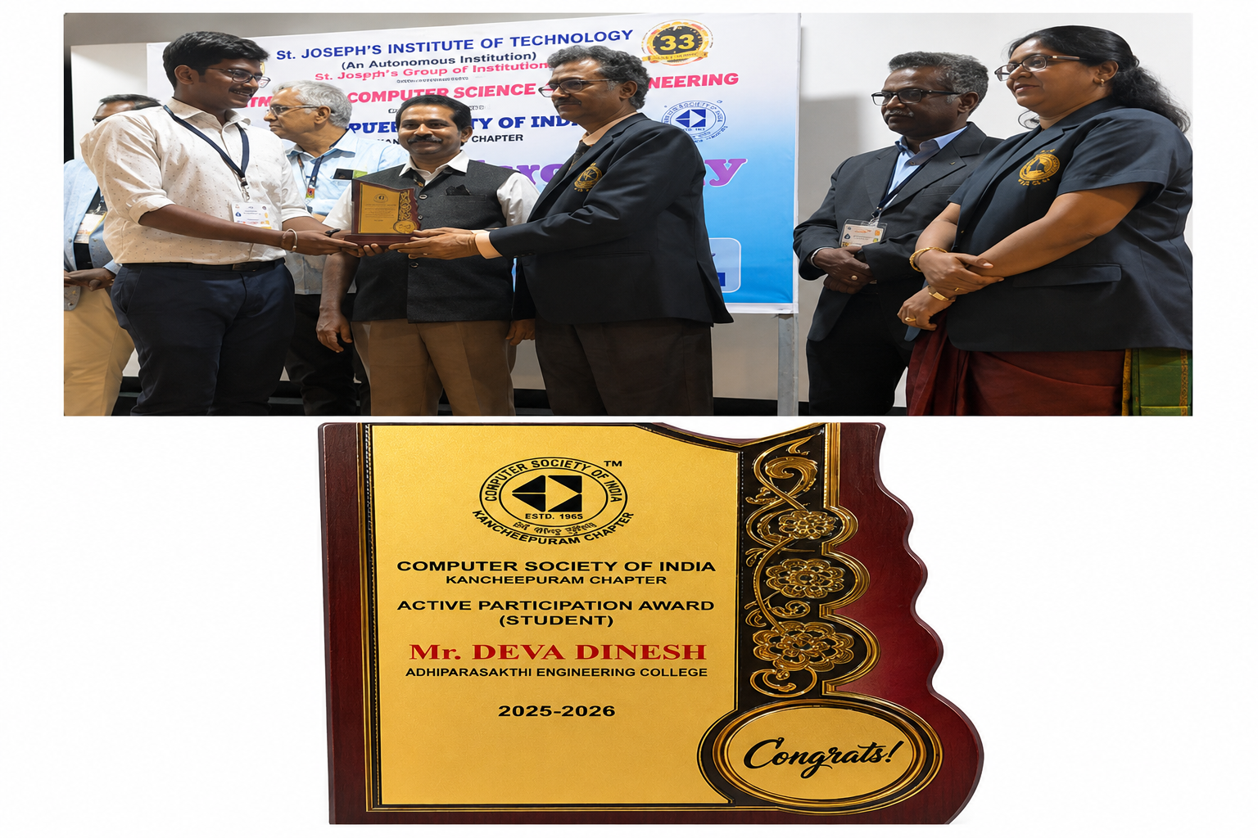
Mr. Deva Dinesh - Active participation Award(Student)
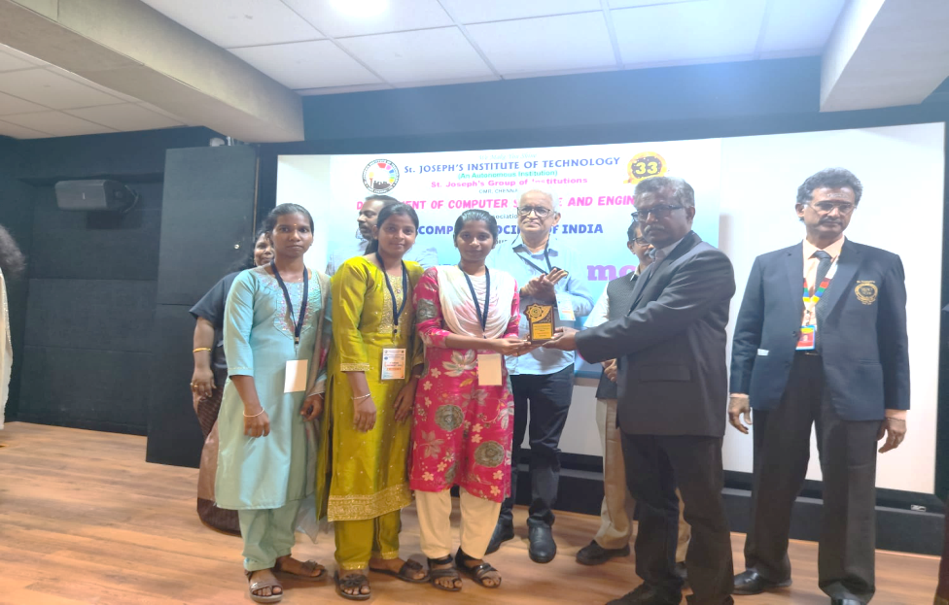
The team comprising J. Sivashree, G. Jeevitha, and V. Monisha received the Best Innovative Project Award at the CSI Kancheepuram Chapter – Region VII Awards for the Academic Year 2025–2026. Their award-winning project, Implementation of Smart Agriculture for Efficient Cultivation in Hilly Regions, was recognized for its innovation and practical contribution to smart farming technologies.
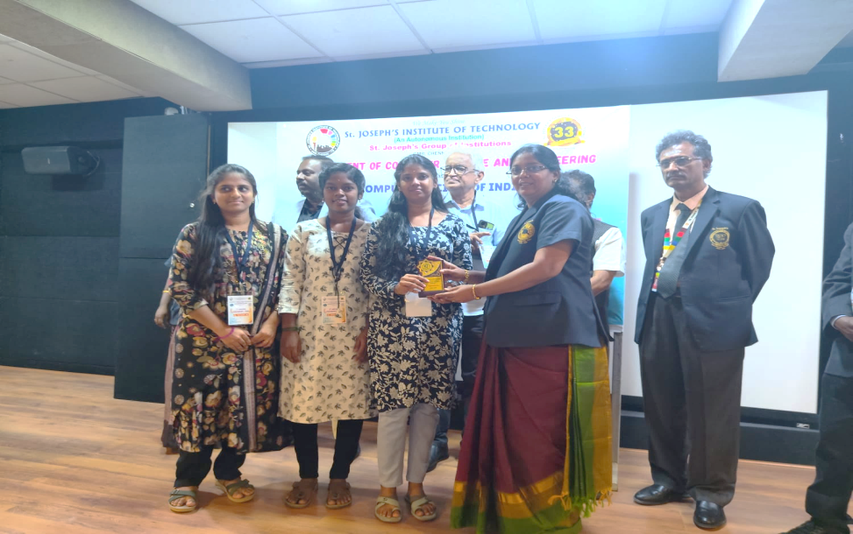
J. Divya, V. Gopika, and D. Kavimathi received the Best Innovative Project Award for their project, Soil Analysis Using Remote Sensing, at the CSI Kancheepuram Chapter – Region VII Awards 2025–2026.
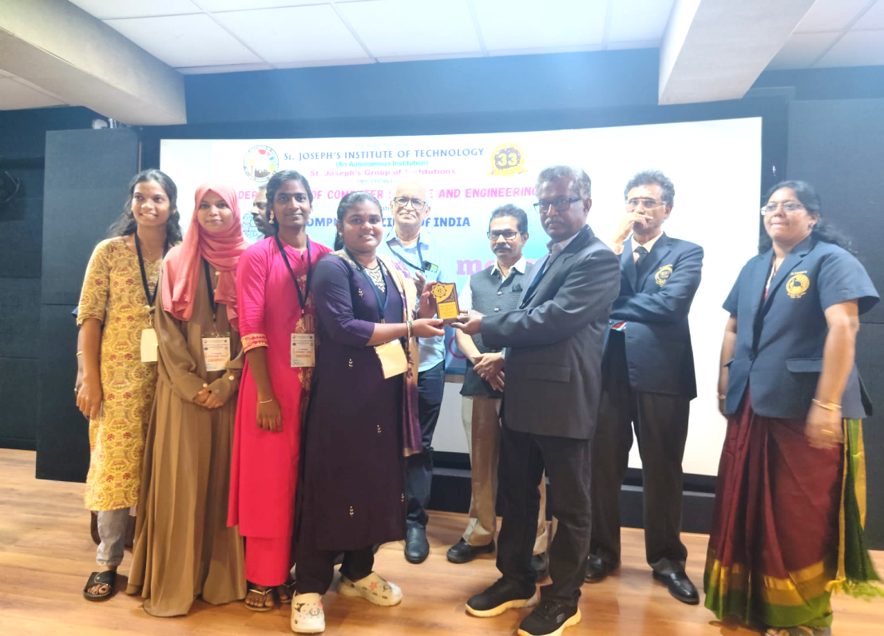
K. Arunthathi, P. Keerthana, A. Roopini, and V. Thowfiqa received the Best Innovative Project Award for their project, IoT-Based Early Detection System for Subclinical Mastitis in Dairy Cows, at the CSI Kancheepuram Chapter – Region VII Awards 2025–2026.
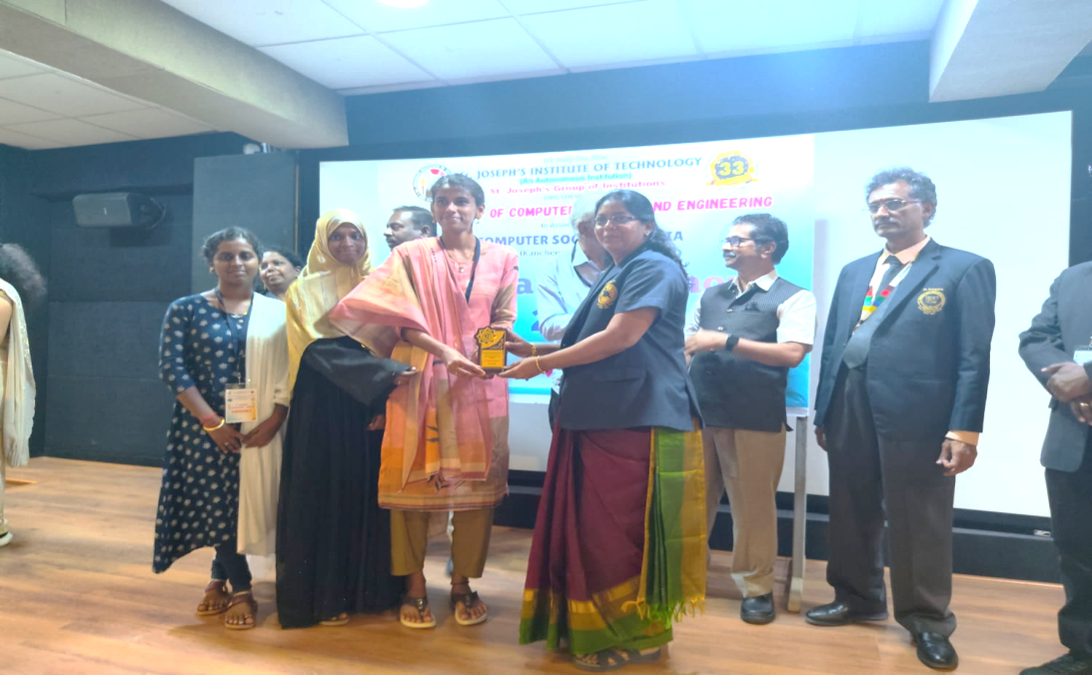
V. Raziabanu, R. Reshma, and M. Kaviyadharshini received the Best Innovative Project Award for their project, An Intelligent Cloud-Based System for Automated Health Risk Assessment and Efficient Rural Medical Service Management, at the CSI Kancheepuram Chapter – Region VII Awards 2025–2026.
SATURDAY ACTIVITY HIGHLIGHTS [25.07.2026]
Saturday Activity was conducted for second-year and third-year students. As part of the event, a poster presentation competition was organized, in which Ms. Srimathi and Mr. Seenuvasan of the third year emerged as the winners.
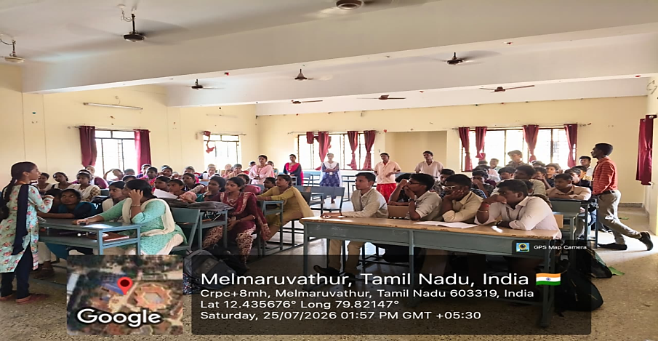
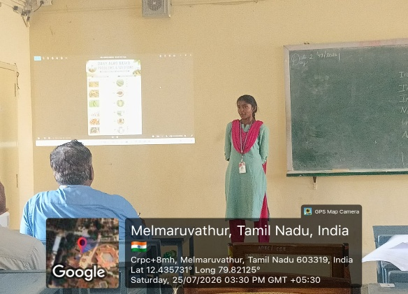
SIH EXPERT TALK: FROM IDEA TO INNOVATION
An Expert Session on “Smart India Hackathon (SIH): Preparation & Insights from an SIH Evaluator” was conducted on 28 July 2026, providing students with valuable guidance on SIH preparation, project development, and evaluation strategies.
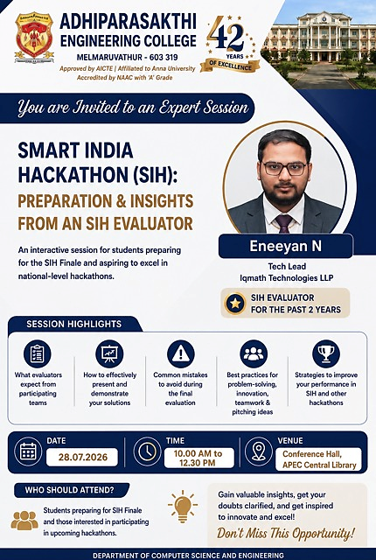

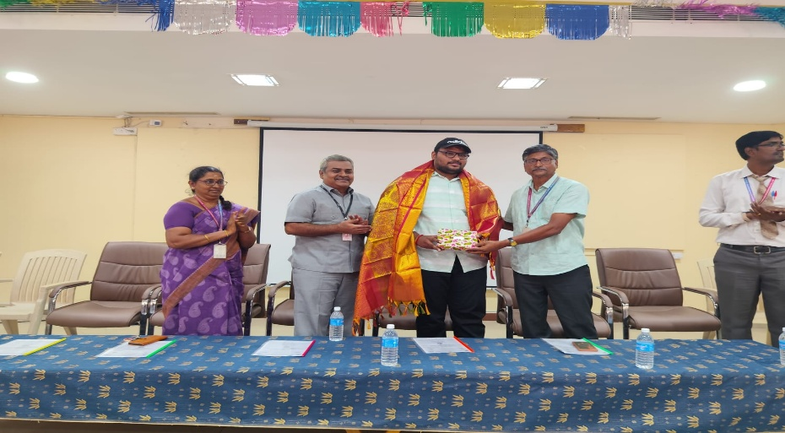

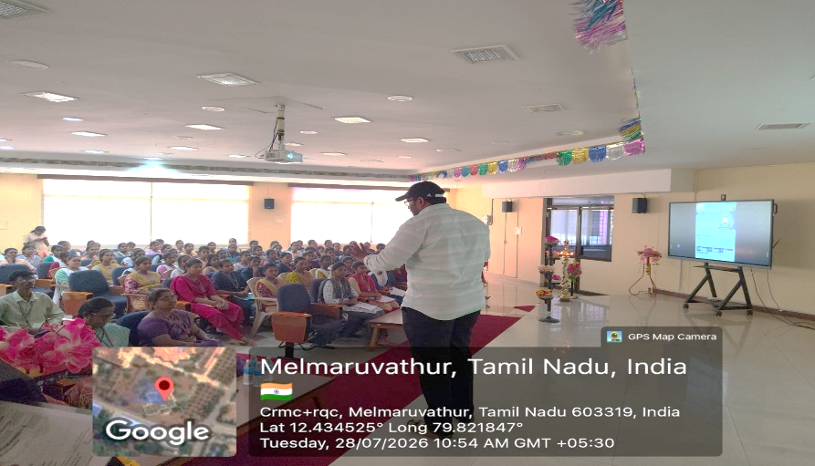

SMART INDIA HACKATHON (SIH) INTRODUCTION SESSION
The Department organized an SIH Introduction Session led by a senior student and previous Smart India Hackathon participant, who shared valuable insights, experiences, and guidance on the hackathon journey.
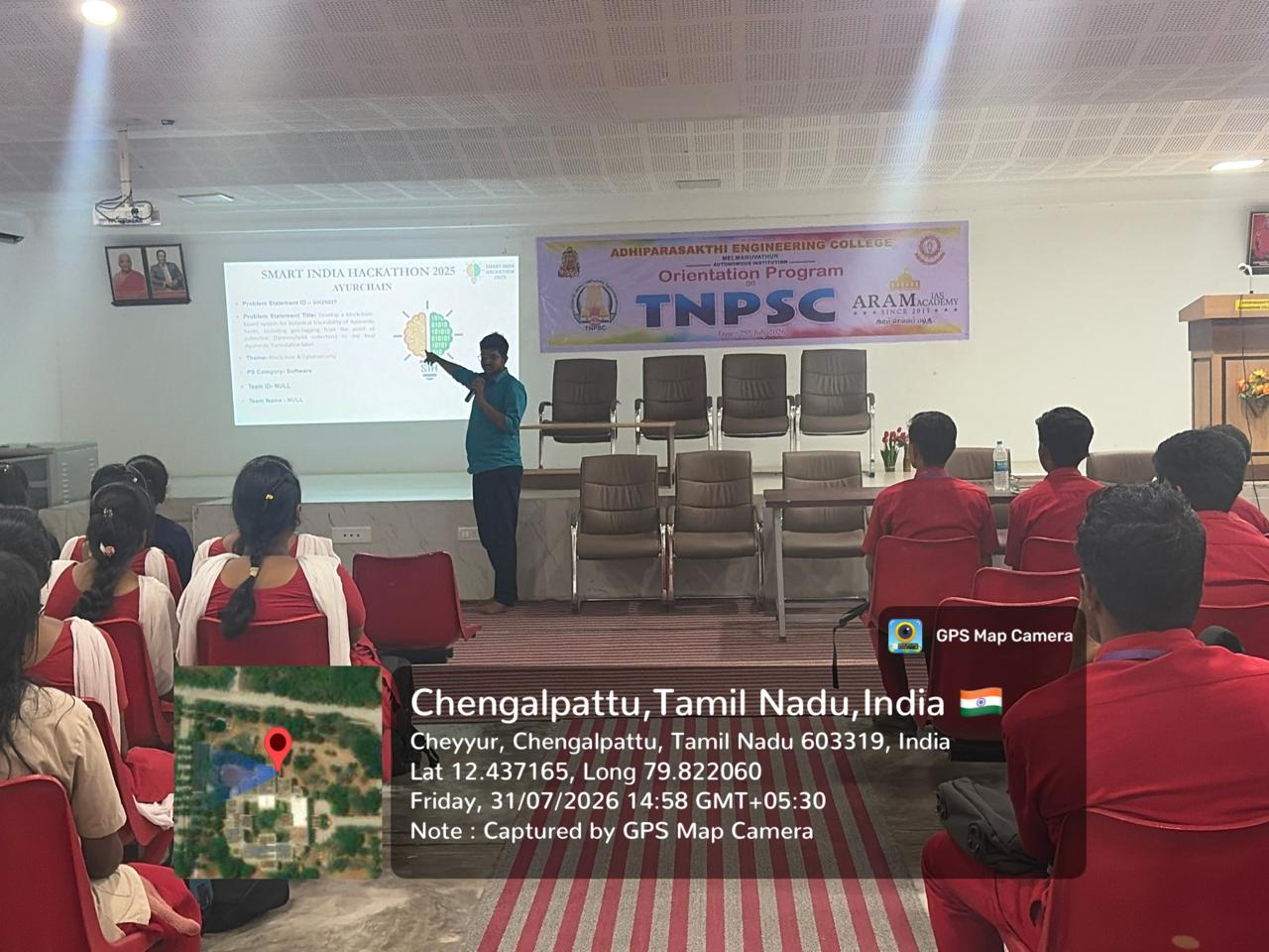

CAREER GUIDANCE SESSION ON STUDYING ABROAD
The Career Guidance Cell organized a webinar on "Higher Education Abroad: Balancing Academics and Part-Time Jobs." The session was delivered by Mr. Thirumanikandan Subramanian, who shared valuable insights on higher education opportunities abroad, student life, and balancing academics with part-time work, inspiring students to pursue global career opportunities.
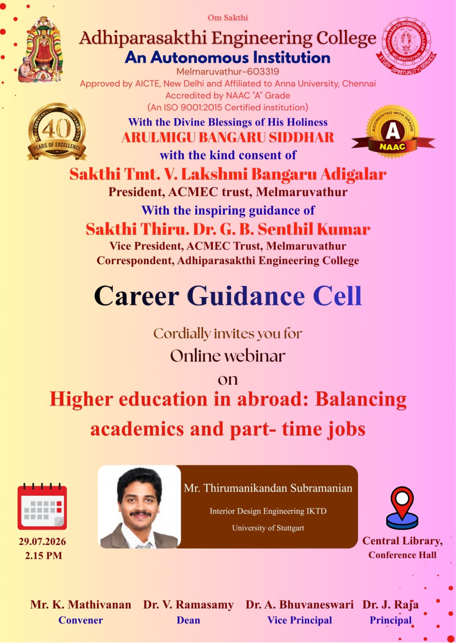

LEARNING BEYOND THE CLASSROOM: INDUSTRIAL VISIT
An Industrial Visit was organized for final-year students to the Mibiz Cyber Forensics Laboratory, Thiruvananthapuram, Kerala, on 30 July 2026, providing valuable exposure to cyber forensics technologies and industry practices.


